

# Bangalore Institute of Technology

## M.Tech, Department of Computer Science and Engineering K R Road, V V Pura, Bengaluru-560004



Mini Project Report on

## "AI Chat Bot"

Submitted as Mini Project for the M.Tech Lab Component of IPCC subject

# Artificial Intelligence and Machine Learning (22SCS22)

## Submitted by Spoorthy UK 1BI22SCS06

For academic year 2022-23

**Under the guidance of Dr. M S Bhargavi Associate Professor Dept. of CSE**



# Bangalore Institute of Technology

## M.Tech, Department of Computer Science and Engineering K R Road, V V Pura, Bengaluru-560004



**LABORATORY CERTIFICATE**

This is to certify that Ms. Spoorthy UK bearing USN 1BI22SCS05 of II semester M.Tech, Computer Science & Engineering has satisfactorily completed the Mini Project for the M.Tech Lab Component of IPCC subject **Artificial Intelligence and Machine Learning (22SCS22)** prescribed by the Visvesvaraya Technological University for the year 2022 - 2023 .



10

**Signature of the staff In-charge**

# **CHAPTER 1**

# INTRODUCTION

* 1. **Overview**

An AI chatbot project involves creating a computer program that can simulate human-like conversations with users using natural language processing and artificial intelligence techniques. This encompasses defining project goals, selecting a technology stack, collecting and preparing training data, implementing natural language understanding, designing dialogue management systems, developing response generation algorithms, training machine learning models, integrating with messaging platforms, ensuring a good user experience, rigorous testing, deployment, ongoing monitoring, and maintenance, while also addressing security, scalability, documentation, and ethical considerations to create a functional and user-friendly chatbot system.

#### Introduction

The project aims to develop an intelligent AI chatbot system that leverages cutting-edge natural language processing and machine learning techniques to facilitate dynamic and meaningful interactions between users and the bot. This chatbot, designed to operate seamlessly on multiple messaging platforms, intends to provide a diverse range of functionalities, including answering user inquiries, assisting with tasks, and engaging in engaging and contextually relevant conversations. Through meticulous data collection, training, and ongoing refinement, the project strives to create a versatile and user-centric chatbot that enhances user experiences, promotes accessibility to information, and exemplifies the potential of AI-driven conversational agents in various domains.In today's digital age, chatbots have emerged as powerful tools for businesses and individuals alike, offering 24/7 accessibility and automated assistance. This project recognizes the growing demand for intelligent chatbots that can seamlessly understand and respond to user queries with nuance and accuracy. Leveraging state-of-the-art natural language processing models and sophisticated dialogue management systems, our chatbot aspires to provide users with a personalized and engaging experience. Whether it's answering customer inquiries, assisting with online transactions, or offering

entertainment and information, our chatbot seeks to be a versatile and adaptable conversational agent that adapts to user needs. Continuous learning and improvement, along with a strong commitment to data privacy and ethical AI, are central to the project's core values, ensuring a chatbot that not only meets but exceeds user expectations in an ever-evolving digital landscape.

* 1. **Scope**

TheThe scope of an AI chatbot project can vary widely depending on its intended purpose and complexity. Here's a general scope breakdown for such a project:

**Functional Scope:**

**User Interaction:** Define the types of user interactions the chatbot will support. This could include answering questions, providing recommendations, handling transactions, or engaging in casual conversations.

**Domain Specificity:** Determine the scope of knowledge or expertise the chatbot will have. Is it a general-purpose chatbot or specialized for a specific industry or task?

**Multilingual Support:** Specify if the chatbot should support multiple languages.

**Integration:** Identify which platforms or applications the chatbot will integrate with, such as websites, messaging apps, or internal systems.

**Technical Scope:**

**NLP and Machine Learning:** Detail the natural language processing (NLP) techniques and machine learning models you'll use for understanding and generating text.

**Data Storage:** Specify where user interactions and data will be stored and how they will be managed.

**Scalability:** Consider how the chatbot will handle a growing user base and increased interactions over time.

**Security:** Define the security measures to protect user data and the chatbot itself from malicious activities.

**User Experience (UX) Scope:**

**User Interface:** If the chatbot has a graphical interface, outline its design and features.

Personalization: Decide if the chatbot will offer personalized experiences based on user history and preferences.

**Testing and Quality Assurance:**

**Test Scenarios:** Define the scenarios and test cases to ensure the chatbot performs as expected.

**Quality Metrics**: Set up metrics and criteria to measure the quality of responses and user satisfaction.

**Training and Data:**

**Training Data**: Specify the data sources and datasets used for training the chatbot.

**Retraining Strategy:** Describe how and when the chatbot will be retrained to improve its performance.

**Deployment and Maintenance:**

**Deployment Plan:** Outline the deployment process, including server setup and configuration.

**Maintenance Schedule:** Plan for regular updates, bug fixes, and improvements.

Legal and Ethical Considerations:

**Privacy Compliance:** Ensure compliance with data privacy regulations like GDPR.

**Ethical Guidelines:** Establish ethical guidelines for the chatbot's behavior and decision-making.

**User Support and Documentation:**

**User Guides:** Develop guides and FAQs to help users understand how to interact with the chatbot.

**Customer Support:** Specify how users can get assistance if they encounter issues.

Monitoring and Analytics:

**Performance Metrics:** Define key performance indicators (KPIs) to assess the chatbot's effectiveness.

**User Feedback:** Set up mechanisms to collect and analyze user feedback for continuous improvement.

**Scaling and Future Enhancements:**

Consider how the chatbot can be scaled or extended in the future to accommodate new features, platforms, or capabilities.

## Applicability

The The applicability of an AI chatbot project is extensive and spans various industries and domains. Here are some common areas where chatbots can be applied effectively:

**Customer Support and Service:** Chatbots can provide instant responses to customer inquiries, troubleshoot common issues, and offer 24/7 support.

**E-commerce and Sales:** Chatbots can assist users with product recommendations, help with the purchase process, and answer questions about products or services.

**Healthcare:**Healthcare chatbots can help users find information about symptoms, schedule appointments, and provide medication reminders.

**Finance and Banking:**Chatbots can assist with account inquiries, transaction history, and even offer financial advice or investment tips.

**Human Resources:**HR chatbots can answer employee questions about policies, benefits, and assist with the onboarding process.

E**ducation:**Educational chatbots can provide tutoring, answer student queries, and offer personalized learning experiences.

**Travel and Hospitality:**Travel chatbots can help users book flights, hotels, or provide information about tourist destinations and local services.

**Entertainment and Gaming:**Chatbots in this domain can engage users in interactive stories, provide game tips, and enhance the gaming experience.

**Information Retrieval:** Chatbots can serve as information portals, helping users find answers to general knowledge questions or locate specific data.

**Government and Public Services:**Chatbots can assist citizens in accessing government services, answer questions about policies, and provide updates on government activities.

**Marketing and Lead Generation:**Chatbots can engage website visitors, gather user data, and provide personalized recommendations, contributing to marketing and lead generation efforts.

**Accessibility:**Chatbots can make digital information more accessible to people with disabilities, providing text-based alternatives to graphical interfaces.

**Internal Business Operations**:Chatbots can streamline internal processes by answering employee queries, automating routine tasks, and assisting with IT support.

**Research and Data Collection**:Chatbots can gather data and feedback from users, making them valuable tools for research and data analysis.

**Social Engagement:**Chatbots on social media platforms can engage with followers, answer common questions, and promote brand engagement.

**Language Learning:**Language learning chatbots can provide language practice and learning exercises to users.

**CHAPTER 2**

# PROBLEM STATEMENT

## Problem Statement

Create a versatile AI chatbot to provide instant, personalized, and cost-effective support, information, and engagement services, meeting the demands of the modern digital world.

## Aim

The primary aim of this project is to design, develop, and deploy an AI chatbot capable of intelligently and efficiently handling user inquiries, providing personalized assistance, and engaging in meaningful conversations across various domains and platforms. This chatbot aims to enhance user experiences, reduce operational costs, and contribute to the accessibility and availability of services in today's digital landscape.

## Objective

* Develop an AI chatbot capable of efficiently handling user queries and providing personalized responses across multiple platforms.
* Enhance user experiences, reduce operational costs, and ensure data privacy through robust security measures and ongoing maintenance.

## Dataset description with Snapshot of dataset

In this project we have not used any particular datasets, here we have used some sentences and some questions and responses to train the chatbot. Here the ChatterBot-based chatbot is being trained using the built-in ChatterBot English corpus, and no external dataset is explicitly mentioned or used for training. The ChatterBot library comes with a pre-built corpus of conversational data that can be used to train the chatbot. This corpus includes a variety of text conversations covering different topics and contexts.

The code snippet that pertains to the training of the ChatterBot-based chatbot is as follows:

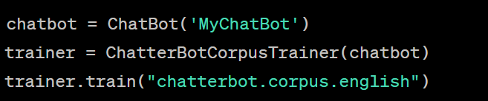

Fig 1: Snapshot-1

In the given context , the list of pairs we've defined can be considered as a form of dataset. This list of pairs contains predefined user inputs (patterns) along with corresponding chatbot responses. Each pair in the list serves as a training example for the rule-based chatbot created using NLTK's chat module.

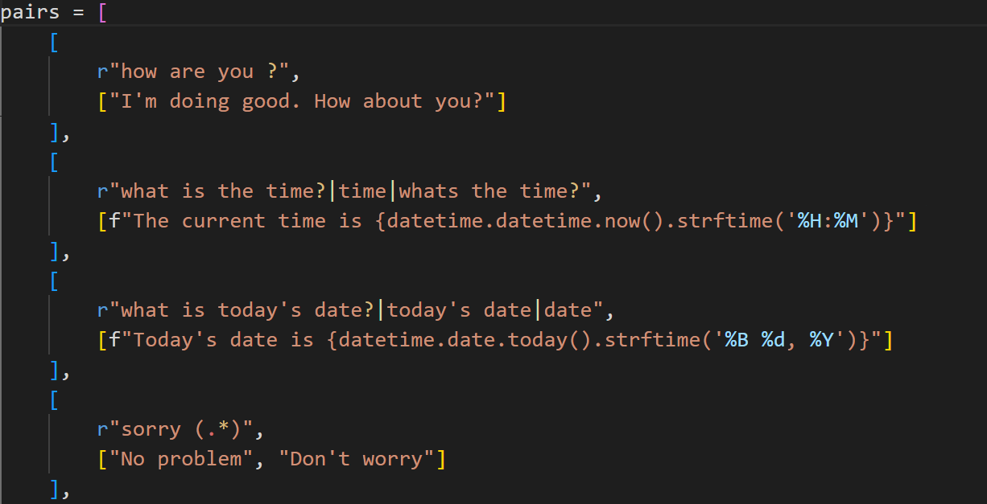

Fig 2: Snapshot-2

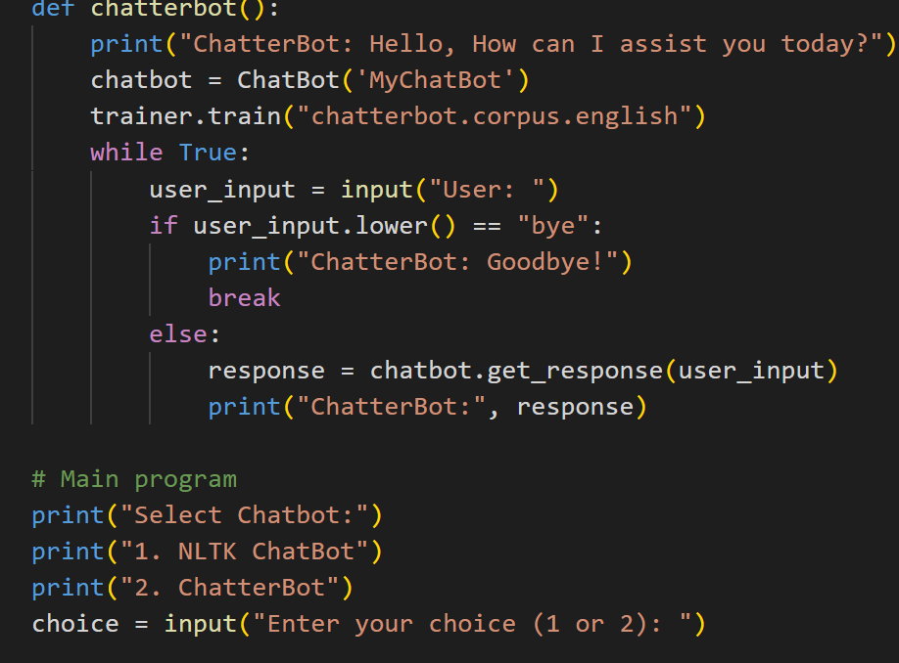

Fig 3: Snapshot-3

**CHAPTER 3**

# SYSTEM REQUIREMENT SPECIFICATION

## Requirement Definition

In the context of this project, "requirements" refer to the detailed descriptions and specifications of what the system should accomplish and how it should function. These requirements serve as a comprehensive guide that outlines the functionalities, features, constraints, and expectations for the system's development. The "Requirements Specification" section of project outlines the specific functionalities and criteria that the proposed system should fulfill. The detailed breakdown of the requirements specification for the project.

### 3.1.2 Functional Requirements

**User Input Processing:**The chatbot must accurately understand and process user input, including text messages, voice commands, or images containing text (if applicable).

**Response Generation:**The chatbot should generate contextually relevant responses based on user queries or commands.It must provide accurate information, instructions, or assistance as per the defined objectives.

**Multi-Platform Compatibility:**The chatbot should function seamlessly on various messaging platforms, websites, or applications as specified.

**Personalization:**The chatbot must personalize responses based on user history, preferences, and behavior, enhancing the user experience.

**Security and Privacy:**The chatbot should adhere to strict security protocols, including user authentication and data encryption, to protect user data and privacy.

### 3.1.2 Non-Functional Requirements

**Performance:**The chatbot must respond quickly and efficiently, even under high user loads, to ensure a smooth user experience.

**Scalability:**The system should be scalable to accommodate a growing user base and increasing interaction volumes without significant performance degradation.

**Reliability:**The chatbot should be available and functional 24/7, with a minimum acceptable uptime percentage.

**Usability:**The user interface (if applicable) should be intuitive and user-friendly, requiring minimal user training.

**Data Privacy and Compliance:**The chatbot must comply with data privacy regulations (e.g., GDPR) and ensure secure storage and handling of user data.

**Security:** It should have robust security measures to protect against data breaches, unauthorized access, and malicious activities.

### Hardware Requirements

**Table 3.2: Hardware Requirements**

|  |  |
| --- | --- |
| **Hardware Component** | **Description** |
| Cloud-Based Environment | Visual Studio Code |
| CPU | Provided by Visual Studio Code(varying specifications depending  on instance type) |
| RAM | Provided by Google Colab (up to 25 GB or more) |
| Internet Connectivity | Required for data retrieval, updates, and interaction with the VS Code environment |

### Software Requirements

**Table 3.3: Software Requirements**

|  |  |
| --- | --- |
| **Requirement** | **Description** |
| Operating System | Windows, Linux, macOS |
| Programming Languages | Python |
| Development Environment | IDE : Visual Studio |

## Summary

In The project's requirements encompass essential hardware and connectivity elements. On the hardware front, it necessitates suitable server infrastructure with ample computational resources, including RAM and CPU capacity, alongside sufficient storage for data storage. In terms of connectivity, a reliable high-speed internet connection is imperative to facilitate real-time communication, complemented by adequate network bandwidth to manage data traffic efficiently. If applicable, domain acquisition and web hosting services should be secured to enable internet accessibility. These requirements collectively ensure the chatbot's effective operation, responsiveness, and accessibility across diverse platforms and user scenarios, while accommodating variable user loads and complexities.

**CHAPTER 4**

# SYSTEM DESIGN

## Dataset Characteristics

* + 1. **Size:** The number of data points (examples) in the dataset. A larger dataset often provides better model generalization but may require more computational resources.
    2. **Variety:** The diversity of data types within the dataset, such as text, images, audio, or structured data. Chatbot datasets often consist of textual data but may include multimedia elements.
    3. **Quality:** The accuracy and reliability of the data, including the presence of errors, noise, or missing values. High-quality data is essential for training accurate models.
    4. **Relevance:** The degree to which the data aligns with the chatbot's intended application or domain. Relevant data ensures that the chatbot can provide meaningful responses.
    5. **Balance:** The distribution of classes or categories within the dataset. A balanced dataset has roughly equal representation of different classes, preventing model bias.
    6. **Annotation:** The presence or absence of annotations, such as labels, tags, or sentiment scores, that provide context or ground truth for the data.
    7. **Volume:** The amount of data available for training, which can impact the model's ability to learn complex patterns.
    8. **Temporal Characteristics:** If the dataset includes time-stamped data, it may capture trends or changes over time.
    9. **Bias:** The potential presence of bias in the dataset, which may affect the chatbot's responses.

**4.2 Tools to be used**

**1. NLTK (Natural Language Toolkit):**

NLTK is a powerful Python library for natural language processing and text analysis. It provides tools and resources for working with human language data, including tokenization, stemming, part-of-speech tagging, and more. In this project, NLTK's `chat` module is used to create the rule-based chatbot. NLTK simplifies text processing tasks, making it easier to implement chatbot behavior based on predefined patterns.

1. **ChatterBot Library:**

ChatterBot is a Python library specifically designed for building chatbots using machine learning techniques. It provides a framework for creating conversational agents that can learn from text data and generate contextually relevant responses. In this project, ChatterBot is used to create the machine learning-based chatbot. It enables the chatbot to learn from the provided dataset and generate responses using algorithms trained on the data.

**3.Datetime Module:**

The built-in `datetime` module in Python is used to work with date and time-related functions. It's utilized to provide real-time information such as the current time and today's date in the responses generated by the chatbots.

**CHAPTER 5**

# IMPLEMENTION

## 5.1 Implementation

Implementation of the AI chatbot project involves the selection of technology stacks, including programming languages, libraries, and frameworks, followed by data collection, preparation, and the development of natural language processing (NLP) techniques for text analysis. Machine learning models are trained and fine-tuned for intent recognition, entity extraction, and response generation. Dialogue management systems handle conversations, while user interfaces are designed for web-based chatbots or integration with messaging platforms. Integration with external systems, comprehensive testing, and security measures are put in place, and ongoing monitoring, documentation, user testing, and ethical considerations are vital elements of the implementation process, ensuring the chatbot functions efficiently and provides a valuable user experience.Machine learning models are a core component of the implementation. These models are developed or selected to perform specific tasks such as intent recognition (understanding the user's goal), entity extraction (identifying relevant information in the user's query), and response generation (crafting meaningful and context-aware responses). Training and fine-tuning these models involve iterative processes, utilizing the prepared dataset to optimize accuracy and performance. Effective dialogue management is essential for handling conversations smoothly. This involves designing a system that tracks conversation context, manages the flow of interactions, and ensures that the chatbot responds coherently across multiple user turns. For web-based chatbots, user interfaces are created to provide a user-friendly experience. Integration with messaging platforms or web services is another key aspect, allowing users to interact with the chatbot through familiar channel

## 5.3 Methodology

The project employs a two-fold methodology to create and compare two different chatbot systems: a rule-based chatbot using NLTK's chat module and a machine learning-based chatbot using the ChatterBot library. Here's a breakdown of the methodology:

1. **Rule-Based Chatbot (NLTK):**

**- Data Collection:** The project begins by defining a list of conversation pairs consisting of user inputs (patterns) and chatbot responses. These pairs represent various scenarios and interactions that the chatbot is expected to handle.

**- NLTK Implementation:**The NLTK library's `chat` module is utilized to create a rule-based chatbot. This involves configuring the predefined patterns and corresponding responses in the form of regular expressions and response lists.

**- User Interaction:**Users are provided with the option to engage with the rule-based chatbot. The chatbot responds based on matching patterns and generating appropriate responses from the predefined list.

2. **Machine Learning-Based Chatbot (ChatterBot):**

**-** **ChatterBot Library Integration:**The ChatterBot library is employed to create a machine learning-based chatbot. This chatbot employs natural language processing and machine learning techniques to generate contextually relevant responses.

**- ChatterBot Training:**The ChatterBot instance is trained using the built-in ChatterBot English corpus. While the code doesn't explicitly detail the training process, the corpus provides a diverse range of conversation examples that the chatbot learns from.

**- User Interaction:** Users are presented with the option to interact with the ChatterBot-based chatbot. The chatbot generates responses based on the training it has undergone on the ChatterBot English corpus.

3. **User Choice and Interaction:**

**- User Selection:**The project allows users to choose between interacting with the rule-based chatbot or the machine learning-based chatbot. This choice determines the type of chatbot the user will engage with.

**- Input and Output:**Users input their queries or messages, and the selected chatbot generates responses accordingly. The interactions aim to demonstrate the capabilities and behavior of both chatbot systems.

## Source code

from nltk.chat.util import Chat, reflections

from chatterbot import ChatBot

from chatterbot.trainers import ChatterBotCorpusTrainer

import datetime

# Simple rule-based chatbot using NLTK

pairs = [

[

r"my name is (.*)",

["Hello %1, How are you today?"]

],

[

r"hi|hey|hello",

["Hello", "Hey there"]

],

[

r"what are you doing?",

["waiting to assist you :)"]

],

[

r"sup|whatsup?",

["Nothing much Sup with you?"]

],

[

r"what is your name ?",

["I am ChatBot,What is your name?"]

],

[

r"how are you ?",

["I'm doing good. How about you?"]

],

[

r"what is the time?|time|whats the time?",

[f"The current time is {datetime.datetime.now().strftime('%H:%M')}"]

],

[

r"what is today's date?|today's date|date",

[f"Today's date is {datetime.date.today().strftime('%B %d, %Y')}"]

],

[

r"sorry (.*)",

["No problem", "Don't worry"]

],

[

r"pick me number from 1 to 10",

["1","2","3","4","5","6","7","8","9","10"]

],

[

r"bye|goodbye",

["Goodbye, take care!", "Nice chatting with you. Goodbye!"]

],

[

r"tell me a joke",

["Why don't scientists trust atoms? Because they make up everything!", "I'm afraid for the calendar. Its days are numbered.",

"Dear Math, grow up and solve your own problems.", "I only know 25 letters of the alphabet. I don't know y."]

],

[

r"that was funny|lol|haha",

["glad you liked it :)"]

],

[

r"what is the time?",

["I'm sorry, I am not programmed to provide real-time information."]

],

[

r"what is your favorite color?",

["I don't have a favorite color. I'm a chatbot!"]

],

[

r"what is the meaning of life?",

["The meaning of life is a philosophical question that has different interpretations for different people."]

],

[

r"where are you from?",

["I am an AI chatbot programmed by OpenAI. I don't have a physical location."]

],

[

r"how old are you?",

["As an AI chatbot, I don't have an age. I'm always learning and improving!"]

],

[

r"what do you like to do?",

["I enjoy having conversations and helping users with their questions."]

],

[

r"what is your purpose?",

["My purpose is to assist users, provide information, and engage in conversations."]

],

[

r"what is the weather like today?",

["I'm sorry, I don't have access to real-time weather information."]

],

[

r"can you recommend a movie?",

["Sure! What genre or type of movie are you interested in?"]

],

[

r"what is your favorite book?",

["As a chatbot, I don't read books. But I can recommend popular ones if you'd like!"]

],

[

r"tell me something fascinating",

["Did you know that the world's oldest known living organism is a tree called Methuselah, which is over 4,800 years old?"]

],

[

r"what is the capital of (.*)",

["The capital of %1 is..."]

],

]

reflections = {

"i am": "you are",

"i was": "you were",

"i": "you",

"i'm": "you are",

"i'd": "you would",

"i've": "you have",

"i'll": "you will",

"my": "your",

"you'll": "I will",

"your": "my",

"yours": "mine",

"you": "me",

"me": "you",

}

chatbot = ChatBot('MyChatBot')

trainer = ChatterBotCorpusTrainer(chatbot)

# Create an NLTK chatbot

def nltk_chatbot():

print("NLTK ChatBot: Hello, How can I assist you today?")

chat = Chat(pairs, reflections)

while True:

user_input = input("User: ")

if user_input.lower() == "bye":

print("NLTK ChatBot: Goodbye!")

break

else:

print("NLTK ChatBot:", chat.respond(user_input))

# Create a ChatterBot chatbot

def chatterbot():

print("ChatterBot: Hello, How can I assist you today?")

chatbot = ChatBot('MyChatBot')

trainer.train("chatterbot.corpus.english")

while True:

user_input = input("User: ")

if user_input.lower() == "bye":

print("ChatterBot: Goodbye!")

break

else:

response = chatbot.get_response(user_input)

print("ChatterBot:", response)

# Main program

print("Select Chatbot:")

print("1. NLTK ChatBot")

print("2. ChatterBot")

choice = input("Enter your choice (1 or 2): ")

if choice == "1":

nltk_chatbot()

elif choice == "2":

chatterbot()

else:

print("Invalid choice. Exiting...")

**CHAPTER 6**

# Results

**RESULTS**

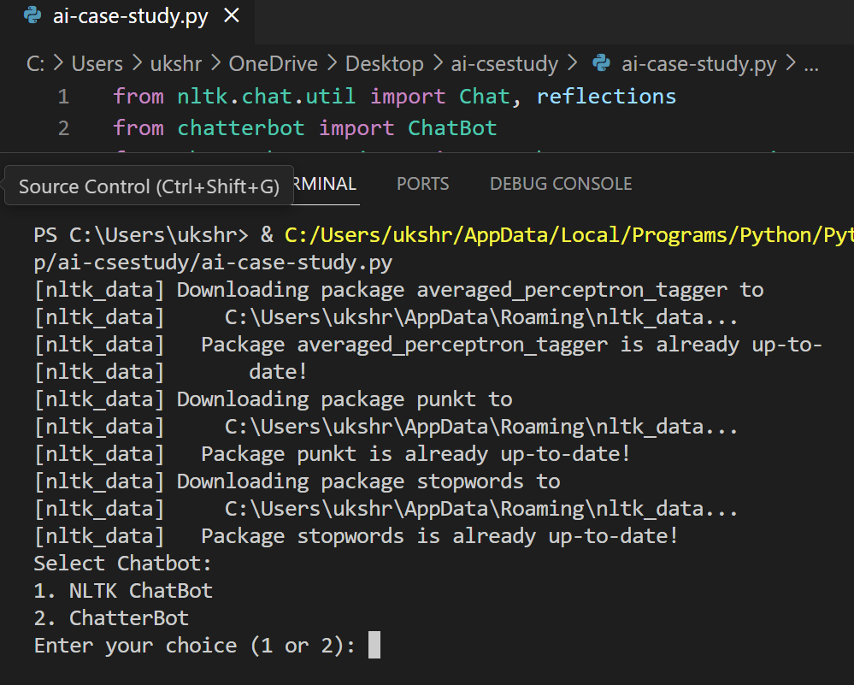

**Figure 6.1: Result Snapshot**

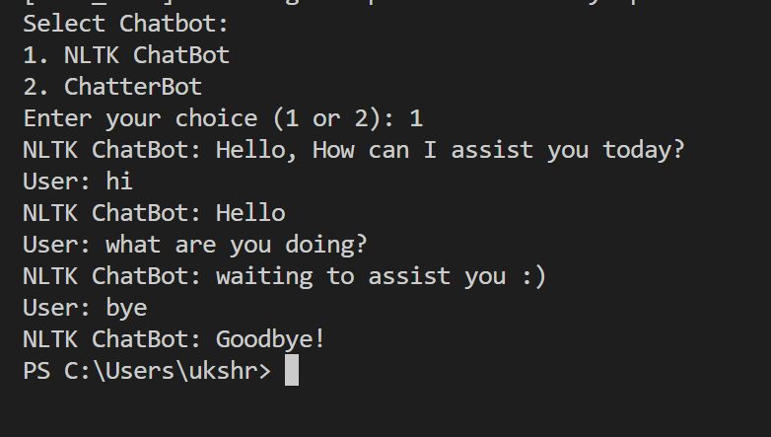

**Figure 6.1: Result Snapshot**

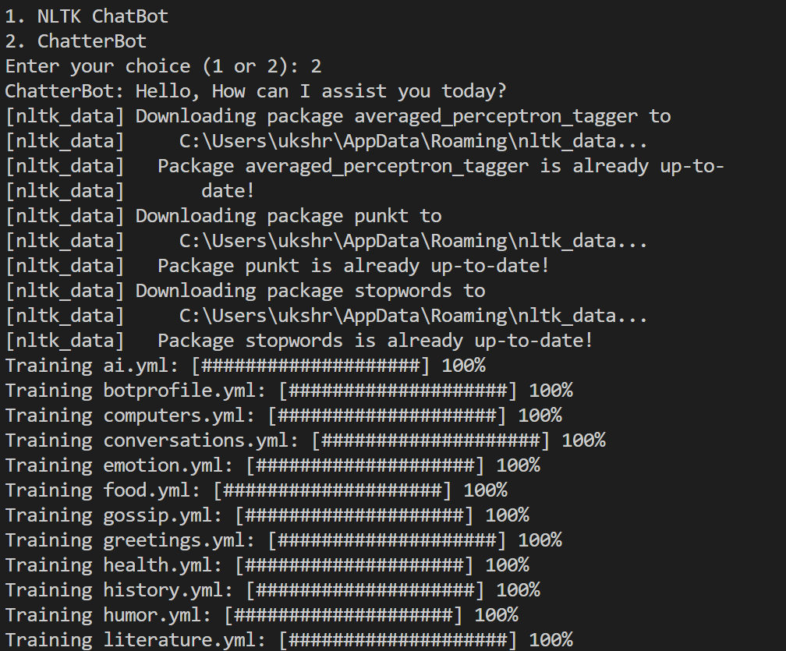

**Figure 6.1: Result Snapshot**

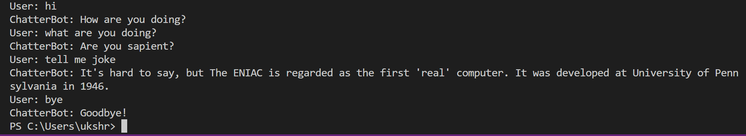

**Figure 6.1: Result Snapshot**

**CHAPTER 7**

# CONCLUSION

## Conclusion

In the ever-evolving landscape of technology, one innovation stands out for its transformative impact on human-computer interactions: chatbots. These intelligent virtual agents, powered by artificial intelligence and natural language processing, hav revolutionized the way we engage with technology and services. In this era of instant communication and automation, chatbots have emerged as essential tools for businesses, organizations, and individuals alike. They serve as versatile conversational interfaces, capable of answering questions, providing information, assisting with tasks, and even offering entertainment.

# REFERENCE

1. Adamopoulou, E., & Moussiades, L. (2020). Chatbots: History, technology, and applications. Machine Learning with Applications, 2, 100006. <https://doi.org/10.1016/j.mlwa.2020.100006>
2. Adam, M., Wessel, M., & Benlian, A. (2021). AI-based Chatbots in customer service and their effects on user compliance. Electronic Markets, 31(2), 427–445. <https://doi.org/10.1007/s12525-020-00414-7>
3. Aggarwal, P., & McGill, A. L. (2007). Is that car smiling at me? Schema congruity as a basis for evaluating anthropomorphized products. Journal of Consumer Research, 34(4), 468–479. <https://doi.org/10.1086/518544>
4. Adler, R. F., Iacobelli, F., & Gutstein, Y. (2016). Are you convinced? A Wizard of Oz study to test emotional vs. rational persuasion strategies in dialogues. Computers in Human Behavior, 57, 75–81. https://doi.org/10.1016/j.chb.2015.12.011